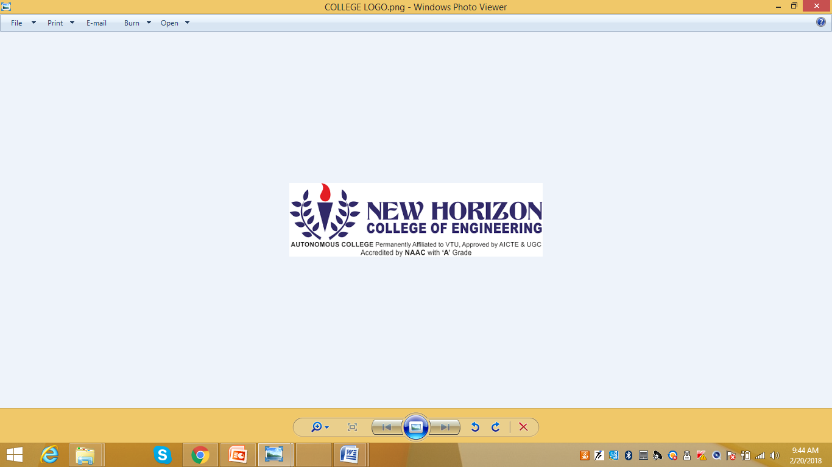

“Noise removal from sine wave using different filters ”
submitted in partial fulfillment for the award of degree of
Bachelor of Engineering
in
Electronics and Communication
Submitted by ,
k.chandrika
Under the guidance of
Mrs.Lipsa Dash
Senior Assistant professor,
Dept. of ECE-NHCE

NEW HORIZON COLLEGE OF ENGINEERING

DEPARTMENT OF ELECTRONICS AND
COMMUNICATION ENGINEERING

CERTIFICATE

Certified that the mini project work entitled “NOISE REMOVAL FROM SINE WAVE USING DIFFERENT FILTERS” carried out by, kamineni.chandrika(1NH18EC048)bonafide students of Electronics and Communication Department, New Horizon College of Engineering, Bangalore.
The mini project report has been approved as it satisfies the academic requirements in respect of mini project work prescribed for the said degree.
Project guide HOD ECE
Mrs.Lipsa Dash Dr. Sanjeev Sharma
Senior Assistant Professor B. Tech M. Tech PhD
Dept of ECE NHCE
NHCE

------------------------- ------------------------

External Viva

Name of Examiner Signature with Date
1.
2.

ACKNOWLEDGEMENT
The satisfaction that accompany the successful completion of any task would be, but impossible without the mention of the people who made it possible, whose constant guidance and encouragement helped us succeed.
We thank Dr. Mohan Manghnani, Chairman of New Horizon Educational Institution, for providing necessary infrastructure and creating good environment.
We also record here the constant encouragement and facilities extended to us by Dr. Manjunatha, Principal, NHCE and Dr. Sanjeev Sharma, head of the department of Electronics and Communication Engineering. We extend sincere gratitude to them.
We sincerely acknowledge the encouragement, timely help and guidance to us by our beloved guide Mrs.Lipsa Dash to complete the project within stipulated time successfully.
Finally, a note of thanks to the teaching and non-teaching staff of electronics and communication department for their co-operation extended to us, who helped us directly or indirectly in this successful completion of mini project.

k.chandrika(1NH18EC048)

TABLE OF CONTENTS

CHAPTER NUMBER | CHAPTER NAME | PAGE NUMBER
1 | INTRODUCTION | 2-4
2 | LITERATURE SURVEY | 5
3 | TECHNOLOGY USED | 6-7
4 | PROPOSED METHODOLOGY | 8-10
5 | APPLICATION | 11-26
6 | ADVANTAGES AND DISADVANTAGES | 27
7 | RESULT OBTAINED | 28
8 | FUTURE SCOPE | 29
9 | REFERENCES | 30

LIST OF FIGURES

SL N0. | FIGURE NUMBER | FIGURE DESCRIPTION | PAGE NUMBER
1 | 1.1 | Noisy Signal | 3
2 | 1.2 | Single Sided Amplitude Spectrum | 3
3 | 1.3 | Response Of Filter | 4
4 | 1.4 | Filtered Wave | 7
5 | 2.1 | Noisy Signal | 8
6 | 2.2 | Smoothed Signal | 12

ABSTRACT

The problem of noise reduction has attracted a considerable amount of research attention over the past several decades. The projects main objective is to filter out the unwanted noise that is attached to the input signal given .
There is no real time signal which is independent of noise in this world. The existence of noise can has led to various improvement in technology for its removal .There are numerous methods that have been developed to enhance the signal from the unwanted noise.
We have used a Matlab code to create a noisy signal and test if the expected outcome is achieved.to perfectly reject .
We always expect an algorithm to have maximal noise reduction without much speech distortion. Fortunately, we show that signal disturbance can be better managed in three different ways.

In signal processing project , the butterworth filter is a ((filter used to produce an estimate of a desired or target random process by linear time-invariant (LTI) filtering of an observed noisy process, assuming known stationary signal and noise spectra, and additive noise.
The Wiener filter minimizes the mean square error between the estimated random process and the desired process.
Noise removal is one of the most needed facility in various fields. Where ever there is involvement of sound propagation or any signal transmission there is definitely the presence of noise.

Even in the basic block of a communication system consists of a noise block indicating that noise is every where which cannot be stopped from occurring but can be suppressed through various methods which removes only some part of it and not completely.
In the olden times the occurrence of noise in any system was comparatively more and the methods involved to reduce it was more tedious. Due to this there was serious impact in the technical field which led to the development of programming methods and also circuit modifications which seemed to be quite helpful .

With increase in technological development the emission of problems also increased which led to more complex programming languages as the technical problems could not solved manually with the help of circuit modifications .
Thus noise is actually considered to be a defect but required in certain fields as it plays an important role in dominating other signal frequencies and renduring a tone that cannot be identified from where it occurs .

Some methods to ignore the noise created by external sources when there is any signal generation like music is by having external barriers like sound proof glass walls. Later a more advanced version is if any kind of music is being recorded the mic is attached with a filter that omits the extra sound that is produced while singing or giving a speech.

CHAPTER ONE: INTRODUCTION

In signal processing, noise is a general term for unwanted ( in general, unknown) modifications that a signal may suffer during capture, storage, transmission, processing, or conversion.

Sometimes the word is also used to mean signals that are random (unpredictable) and carry no useful information; even if they are not interfering with other signals or may have been introduced intentionally, as in comfort noise.

Our ears are the most sophisticated detector of noise that is heard like an analog signal in nature. Such type of noise causes irritation and discomfort to us. But this can only be heard but cannot be seen.

This project focuses on being able to see this noise wave on our screen which involves a lot programing codes and also live representation on describing the method to rmove such noise in our software.

There are various types of noise seen in various electronic gadgets even from the simplest circuit and a more complex circuit designed using a software. One such method to filter that out is being performed here by using the matlab software.

There are numerous filters depending on the type of frequency response required. There are various filters namely low pass ,high pass, band pass and band reject filters. Here the filter used is a Butter worth filter which is a low pass filter that passes the frequencies below the cut of frequency and attenuates the remaining as the exceed the cut off.

Out of all filter types butter worth filter seems to be more useful as the pass band . It is also referred to as a maximally flat magnitude filter.

This project follows a simple structure or algorithm to execute the program .We have distinct parameters that have to be looked upon for the construction of the code. Due to such representation it gives us a better understanding on the newly developed methods that can generate an accurate ouput from the disturbed signal.

CHAPTER TWO: LITERATURE SURVEY

Title of the paper | Author & Year of Publication | Outcome
Electronic filter simulation and design | Giovannidianchi and Roberto Sorrentino  2007 | Filtered wave
Microware Filters | Mattheai, George  1964 | Butterworth Filtered Wave
Linear Estimation | Thomos kaliath  2000 | Based on weiner filter

CHAPTER THREE: TECHNOLOGY USED

It only involves the matlab software that is used to implement the code.The mainly used matlab environment which provide the required parameters involved in constructing the outline of the project. ​In order to set a new noise Standard in future, an understanding of current research and technology development is imperative.

Technological progress continues to push the technological industries to delivering on the goal of limiting or reducing the number of people affected by significant aircraft noise. There is a firm that continually monitors research and development in noise reduction technology, and this complements the Standard-setting process.

Amongst the numerous methods of noise removal the optimal Wiener filter can be considered as one of the most fundamental noise reduction approaches, which has been delineated in different forms and adopted in various applications.
Although it is not a secret that the Wiener filter may cause some detrimental effects to the speech signal (appreciable or even significant degradation in quality or intelligibility), few efforts have been reported to show the inherent relationship between noise reduction and wave distortion.

Thus we use a butterworth filter in our project design which is also known as maximally flat magnitude filter that provides a pass band response also equivalent to a straight line. And also we use the savitzky-golay filter in the project.The type of filter and the construction of filter for the desired output is seen in detail to provide the required outcomes.

Thus matlab supports this idealogy in implementing the code to obtain the required output.This software was developed in the late 1970’s .This was not considered to be a highly sophisticated software but it was mainly developed to perform matrix calculations for highly complex and large matrices as the manual calculations seemed to be highly impossible to do.

It was developed by Mr.Cleve Moler who was the chairman of the computer science department in new mexico university .He developed it so that his students could get access to the LINKPAC which is a library that is used to perform linaear algebra for complicated equations on the computer .
It was also developed to create a path for the easy access for EISPACK that is used for calculating eigen vectors ,eigen values,rank of matrix and other mathematical operations which involved any matrix type.

It was first used by control engineers and only for professionals at jobs but later the importance of it shifted from the professional domain to the education domain as it would make it easier for the graduates to cope up with the programming language during work time.
It was later appreciated and gained a lot of interest by the students and thus it was impleamented in other universities and later there were other developments in the software called LAPACK which is a softwar library and a combination of bit linkpac and eispack which reduced a lot of complications in the initial software.
It has various structures within it and each type has a particular form of syntax that can be implemented. All the structure types can be put under specific type namely :
- Variable
- Functions
- Function handlers
- Vectors and matrices
- Object oriented programming
- Interfacing programming
- Interfacing with other language
These are the key blocks of the software every type has its own specifications as to what functions are under each category .Given below are the simplest definition and importance of each category as to how using it is in using it as a programming platform and also the different modifications that has been done over time to update the older version and improve the complexity of the older version with respect to the newly developed technological barriers.
- Variables:
Variables are the typical alphabets that are used to assign any value or used for declaring any number or operations

- Functions:
Functions are keywords that are already present in the software that can be called to perform any particular operation.The keyword’s name can be the same as the operation it performs or can be the shortform of that particular operation.
For example the convolution operation uses a keyword “conv” .Once this word is typed we are required to mentin the two variable that contain the input which needs to be convolved.

- Function Handlers:
Function handlers are the high level operations like gamma function or lambda calculations .

- Vector and matrices:
Vectors and matrices are a basic form for declaring arrays and assigning vaues for the matrix to perform any mathematical operation.

- Object oriented programming:
Object oriented programming used the keyword “object” which includes classes, pass by reference which is equivalent to a main function in c.

- Interfacing programming:
Interfacing programming is the development of the code into a pictorial or a graphical form of representing the written code .And matlab has the graphical user interface development environment that enables the user to see the plot of any equation or and 2 dimensional plots.

Through updating to the recent times matlab enables three dimensional plots that gives rise to better understanding of the keywords of the code.
This is the overview of the software that has been used. Now we can understand the keywords more specifically .

In the older days when there was no programm. language all circuits had to be designed manually on bread boards thus it was very tedious to find out how the signal gets disturbed which affected the circuit performance.

Thus detecting the fault was very difficult thus the circuit leads had to made very small in order to reduce the complexity of the circuit understanding . Even though there were many parameters that had to looked upon there was no solution to irradicate the noise completely.

This led to the development of softwares where the circuit was designed with the help of components that was already progrmmed to exist in the software which reduced the labor time involved in rigging up the circuit manually.
Even when such circuit softwares were available still the rectification and development of the present circuit seemed to be very difficult.

Due to such drawbacks alternative methods had to be developed which led to the development of other programming languages.

Now coming to the white noise that plays an important role in this project. It is a primitive type of signal form ,in circuits is it mainly created due to elongated wires that are used and the noise is generated along the length of the wire and increases along the length.

It mostly occurs in audio signals or in music industries where white noise is purposely added while creating electronic music that is composition of tunes using the music software’s and at times it is added inorder to modify the present sound according to the users wish
.
Another place where it can be seen is in concert set ups where the amplifiers are used for instruments like guitar and keyboard which is attached with a processor along with the amplifier .

The amplifier wire generates some form of noise and that is being modified by the processor or eliminated according to the performers choice.

In terms of mathematical definitions a random noise is a random vector that is partially imaginary which has a mean of zero are noise propagates in all directions and the variance is a numerical or any finite value.

It is basically a noise that we hear without even noticing it.By combining all frequencies of various waves into one we call it the white noise.

A common example where it can be seen live is in fans. When a fan is switched on the movement of air around it creates a hushing sound and that sound may note hit a particular note in music but it is a mixed pattern of such sounds .

Which creates a background noise by masking all other sounds around it. Such type of noise helps in suppressing the other noise snd reduce the disturbance created by all other sources .

lows a simple structure or algorithm to execute the program .We have distinct parameters that have to be looked upon for the construction of the code. Due to such representation it gives us a better understanding on the newly developed methods that can generate an accurate ouput from the disturbed signal.

The type of noise that is used in this project is white noise which random signal which has a constant power density. It refers to a statistical model of signals and not a single signal. It is basically a signal containing many frequencies with equal intensities. There are other types of noise like:
- Continuous noise :
that which like a loud noise that usually occurs in machineries

- Intermittent noise:
this type of noise has various fluctuations like increase and decrease in amplitude and frequency .It is a typical type of a random signal. Such noise cannot be measured accurately it can only be measured through the duration of occurance of a similar noise pattern signal.

- Impulsive noise:
A sudden increase in noise amplitude or intensity very commonly observed in explosions and construction site.

- Atmospheric noise:
The lightning noise or the noise that is less than 20 mega hertz.

- Cosmic noise:
the frequency of noise that lie between 8MHz to 1.5GHz

- White noise:
The noise with constant spectral density over a certain range of frequency this noise is used in our project which is being removed through matlab.

- Shot noise:
Bipolar transistors (due to random arrival of electrons and holes geeting accumulated in its output terminal which affects the function of the internal circuitry of any amplifying or intergrated circuit devices.

- Thermal noise:
Noise generated due to the occurance of heat that happens due to movement of electrons within any device .the bandwidth is observed to be infinity as once the steady state of the noisy wave is obtained it cannot be stopped thus it will keep propagating throughout .

- Flicker noise :
This noise is generated due to diffusion of the electrons and holes in the transistor.This is almost similar to shot noise but the only difference is that it occurs once the diffusion takes place that is after shot noise.

- Pink noise:
It is a low frequency noise like flicker noise also known as indirect frequency noise as it depends on the inverse of the actual frequency.
All these categories of noise come under two main types depending on how the noise is being caused and where it caused within the specified environment they are

- Internal:
This noise is seen inside the circuit and the movement of electrons or the accumulation of the elctrons within the components and also due irregularities in the components .With respect to computer programming such errors can be seen clearly
for example any audio signal can be edited according to the users wish where we can observe the disturbance and distortions in the wave.

- External:
This noise type can be seen due to external factors like voltage supply errors ,connectivity issues and other man made factors. Thus these factors gives rise increase or decrease of the actual value that is required.

- Linear System:
A linear filter is one that can be done with a convolution which is just an linear sum of values in a sliding window.It can be done equivalently in the Fourier domains by multiplying the spectrum by an image.

Linear filters process time-varying input signals to produce output signals, subject to the constraint of linearity. most cases these linear filters are also time invariant in which case they can be analyzed exactly using LTI ("linear time-invariant") system theory revealing to their transfer functions in the frequency domain and their impulse responses in that time domain. Real-time implementations are such linear signal processing filters in the time domain are inevitably causal, an additional constraint on their transfer functions.

- Non-linear system:
A non-linear filter was a filter whose output is not a linear function of its inputs. If the filter outputs signal R and S for two input signal r and s seperately , but does not as always output aR + bS.A non-linear filter was one that cannot be done with convolution or Fourier multipilication.

Both continuous-domain and discrete-domain filters may be nonlinear. A simple example of the former would be an electrical device whose output voltage R(t) at any moment is the square of the input voltage r(t); or which is the input clipped to a fixed range [a,b], namely R(t) = max(a, min(b, r(t))). And important example of the latter is the running-median filter, such that every output sample Ri is of the last three input samples ri, ri−1, ri−2. Like linear filters, nonlinear filters may be shift invariant or not.

Non-linear filters have many applications, especially in the removal of certain types of noise that are not additive. For example, the median filter is widely used to the remove spike noise — that affects only a small percentage of the samples, possibly by very large amounts. Indeed, all radio receivers use non-linear filters to convert kilo- to gigahertz signals to the audio frequency range; and all digital signal processing depends on non-linear filters (analog-to-digital converters) to transform analog signals to binary numbers.

CHAPTER FOUR: PROPOSED METHODOLOGY

Noise reduction , the recovery of the original signal from the noise-corrupted one, is a very common goal in the design of signal processing systems, especially filters. To reduce the background noise and suppress the interfering signals by removing some frequencies is called as filtering. Few continuous time filters

- Chebyshev filter
- Bessel filter
- Savitzky-golay filter
- Butterworth filter

The project involves sequential execution of steps to see the required result in a proper order and the methodology that has been followed is:
Firstly we create the type of signal that is the primary input to the project in out case it is the sine wave. It is a keyword “sin(x)” where ‘x’ written within the bracket here is the frequency or time period for one complete cycle this has to be specifying inorder to be plotted.
Once the sine function is declared with the appropriate frequency it has to be plotted using the keyword “plot” since we deal with time domain signals the word used is plot but for discreate signals the method to plot the signal is by using the word stem.
Secondly the next part of the program that the addition of the random noise to the sine wave to convert it into a distusavirbed input which is the required signal .
The keyword used is “(a)rand(l)” where a is the amplitude of the signal in our case it is almost equal to the sine wave and l is the length of the signal.Since it is a dissimilar wave there can not be any time period thus we specify the range of it as to how long it should extend.

After the random signal is generated it must be plotted over the sine wave thus we overlap both the signals to create a distorted wave
Thirdly we calculate the maximum peak attained by the wave by calculating the amplitude spectrum of the disturbed wave .The fft is calculated and is it plotted by taking the frequency on the x-axis and the absolute amplitude on the y-axis.

- Creating noisy signal:

The type of signal that has been considered to be the initial input of the project is a sine wave that have a noise signal of equal amplitude and intensity attached to it. This gives rise the creation of a random noisy signal. The type of signal that generates the noisy part of the sine wave is he white noise.
The main agenda of this project is to eliminate that noise and give out a pure wave. Once the random signal is generated with equal intensity of the sine wave both the plots are made to overlap just to show us a pattern of uniformly disturbed waves.
Due to the presence of white noise which has infinite bandwidth it is important for us to limit its action by designing a filter that has a cut off frequency less than the higher cut off frequency of the noisy wave which helps in reducing the extra complexity of the infinite signal.
- Finding amplitude spectrum:

The next step is to find out the magnitude of the noisy signal in order to measure the actual peak value of the wave . The input signal is seen to have many shifts along the axis which leads to a confusion in finding the amplitude but due to the help of matlab this job has become more easy.

We know that the sine wave is a periodic continuous signal and the random signal is just a design of various signals over a the specified time limit .To find the amplitude of two such mixed waves matlab supports such cases of waves and has inbuilt functions that can examine the maximum amplitude of the and the number of times it occurs along the time axis.

With this we can easily evaluate the amplitude in our case since we specify the amplitude in the beginning of generating the signal we just verify if the same amplitude is detected by the software.

- Filter design:

The filter that has been opted in this project is a low pass butter worth filter. Any filter can has various Q factors and the q factor that has been considered here is 0.707 for which the frequency response obtained has a flat pass band.

It was developed by the physicist named Stephen Butterworth. According to him a filter must nit completely cut off the unwanted frequency and also be sensitive towards the wanted frequencies .

As that cretiria cannot be satisfied as any electrical appliance will definitely have some error corrections .The filter was developed in 1930’s and the frequency response for a first order system is like to have a -6db per octave or -20db per decade rate of fall.

Choosing the proper quality factor is very important as the frequency response at every different value of q factor will give rise to a different frequency response .

For example if the quality factor is above 0.707 the gain at the cut off frequency will have a ripple and similarly if the quality factor is below 0.707 the width of the pass band reduces which affect the ouput when the nisy signganl is sent to the filter this may cause the filter to clip out certain portion of the signal and the requied output may not be seen .

Thus it is important to look into the parameters while designing the filter and any modifications that is done, the response mustn’t vary which is why the quality factor opted in this project is 0.707.

Unlike other filters that which have non-monotonical ripples in the pass band the butterworth filter have monotonic changes in the magnitude and also have a linear phase response in pass band when compared to other filters.

The butterworth filter is very much stable when compared to other filters thus requires higher order to make a specific stop band point .

- Signal passed through filter:

The final step is passing the noisy signal through the constructed filter. This leads to the filter to pass the signal till the cut off frequency and the remaining part is attenuated.

Once the code is done typing the plots can be observed by running the program. From the above mentioned key points we obtain their respective plot on the window.

The obtained graphical plots can be developed by dumping it on an fpga kit or dsp kit to see a practical functioning of the code.

From each key point that has been mentioned one plot has been taken for each sub heading . The plots are observed in form of a matrix where the images are placed sequentially depending on the number of plots that are expected to be seen.

Methods of implementing the matlab code into practical applications:
By normal graphical method where the code specify’s as to what must be plotted and the description of the x and y axis are user defined .Thus the plots can be observed once the complete code is written. This is one of the facility that matlab provides and any type of wave can be generated by using the appropriate keywords and syntax.

Another method is by implementing the same code in another programming language by using the required syntax and it can be downloaded on practical purpose devices that are mentioned below.

The next advanced method of implementing is by converting the code to its equivalent c code and implementing with the help of the dsp kit .

The other device is the fpga which requires the programming language named Verilog which has its own programming syntax inorder to generate the same code.

There is another menthod to see a the ouput that is using the Simulink option that has recently come into picture in the matlab software where there are specific function blocks for every single operation and the waveform can be observed using the opion called scope.

Flow chart
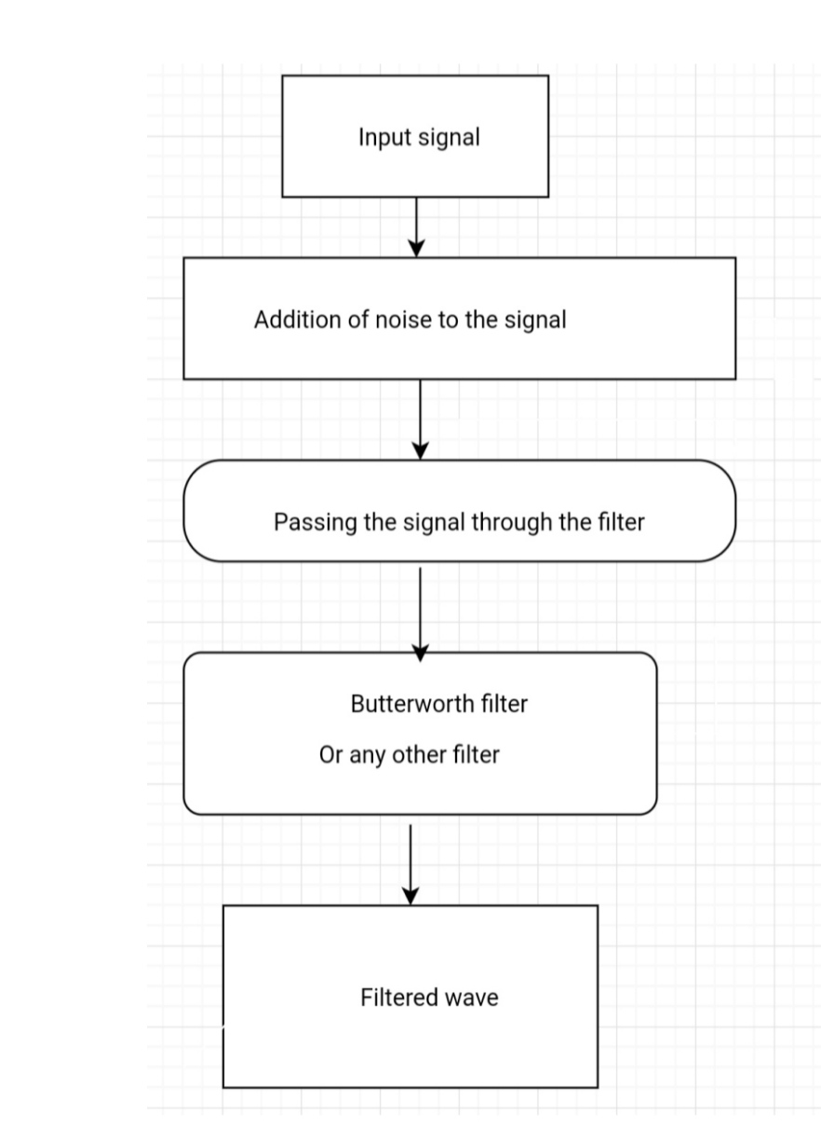
CHAPTER FIVE: RESULT OBTAINED
The following results have been obtained in form of a graph through matlab simulation.This is for Butterworth filter
There were four plots that were obtained
- The first plot is the input signal or the noisy signal which is a combination of sine wave and white noise.

- The second plot is the amplitude spectrum that indicates the highest value of magnitude if the signal that has been observed from the input signal.

- The third plot is the frequency response of the butter worth filter that has been designed for a specific higher cut-off frequency.

- The final plot is the result obtained after passing the signal through the filter. The wave is not of the the desired amplitude due to the filter design which passes the frquency from the minimum value.

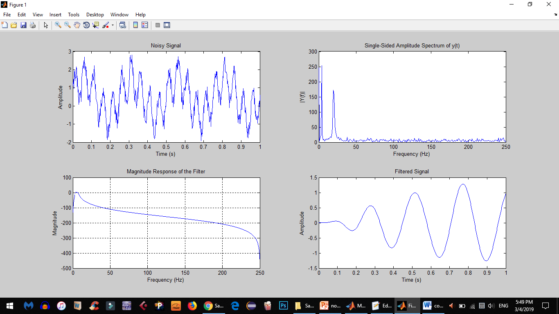

NOISY SIGNAL

SINGLE SIDED AMPLITUDE SPECTRUM

RESPONSE OF FILTER

d)FILTERED WAVE

The following results have been obtained in the form of graph through the matlab.This is for savitzky-golay filter.

There were two plots that were obtained
- The first plot is the input signal or the noisy signal which is a combination of sine wave and white noise.

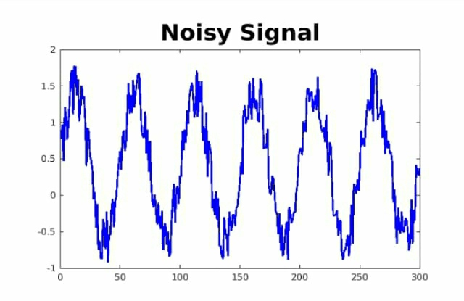

- The final plot is the result obtained after passing the signal through the filter.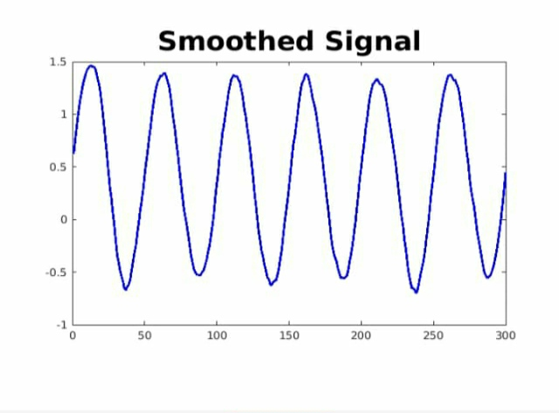

CHAPTER SIX :FUTURE SCOPE

The project is very useful in under standing the concepts of dsp and it is a very important for the concept electronics and communication engineers as jobs are available that deals with respect to communication.

Another main important application is that the project as of now is a matlab code which can further be developed by down loading the code on a dsp kit by converting in to a c program.

Or into an fpga by converting it in to a Verilog or vhdl code and from that it can be implemented in a ucf file and then a real time signal can be given and the outcomes can be tested.

Such development of simple nise removal methods can be implemented in daily basis that involve any type of audio filtering and developeing it to filter images as well.

One of the most important purpose of this project can help in medical field where the pulse rate is being measured using the ecg and there may occur various errors due to external factors thus filtering is required in the ecg machines.

The music industries need such software to record any type of audio or speech that can provide clarity and quality in their work

CHAPTER SEVEN:ADVANTAGES AND DISADVANTAGES

- BUTTERWORTH FILTER
ADVANTAGES
1.Easy to implement in electronic circuit.

DISADVANTAGES
1.Introduces a phase shift. 2.Sloution is to apply it twice in opposite directions.

- SAVITZKY-GOLAY FILTER
ADVANTAGES
1.The main advantage of this filter is that it will preserve features of the distribution namely the relative macimum minima and width which are usually flatterned by any other adjacent averaging technique
2.SG filters are typically used to smoothout a noisy signal who's frequecy span is large

DISADVANTAGES
1. The main disadvantage of the SG filter is that a small amount of experimentation in normally required to verify the appropriate filter who's values require to best filter a specific filter

REFERENCE

The project title was being selected from google.
Other websites that were used for further references are:
Howstuffworks.com
Minicircuits.com
Mathworks.com
https://youtu.be/yqqs|YRYnPE
https://youtu.be/KdujjlrK40o

